TASK 3: HOW TO CREATE FIRST JENKINS JOB

Create a Freestyle project and name it as HelloWorld 2 Select “Execute shell” under “Build” section 3 Enter the commands echo "Hello World " echo "Welcome to Jenkins“ 4 Save and build now

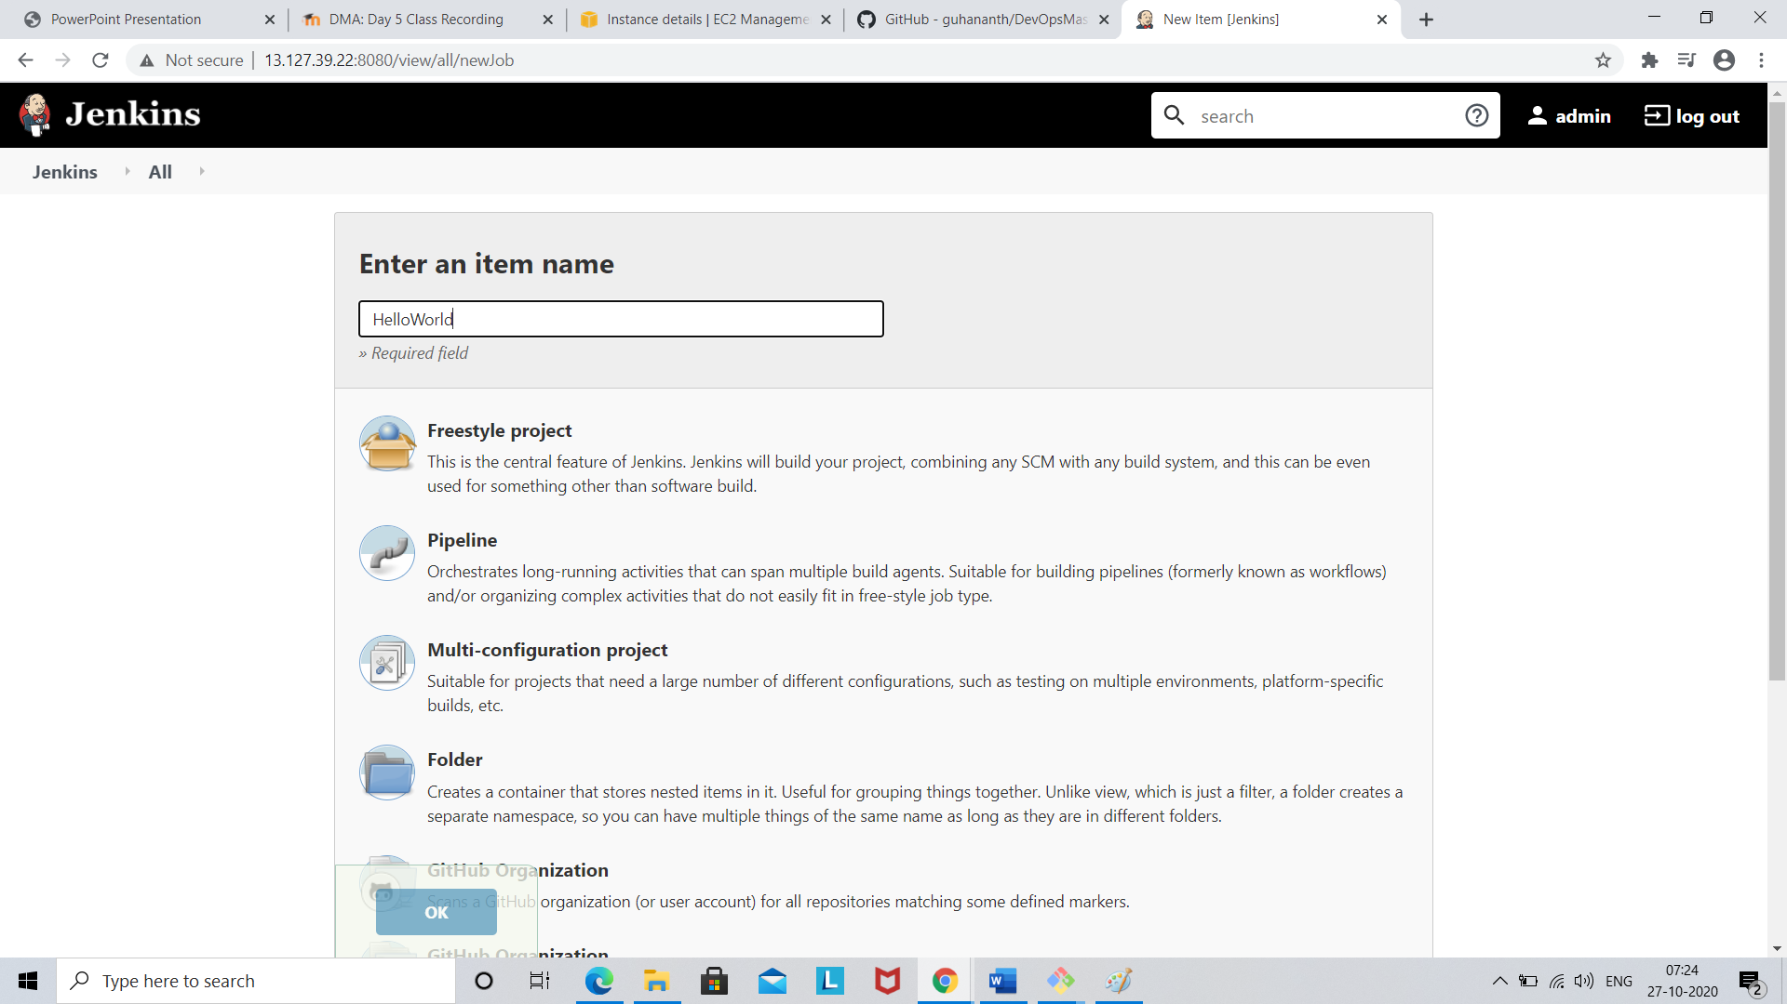

Click free style project

Enter name as HelloWorld

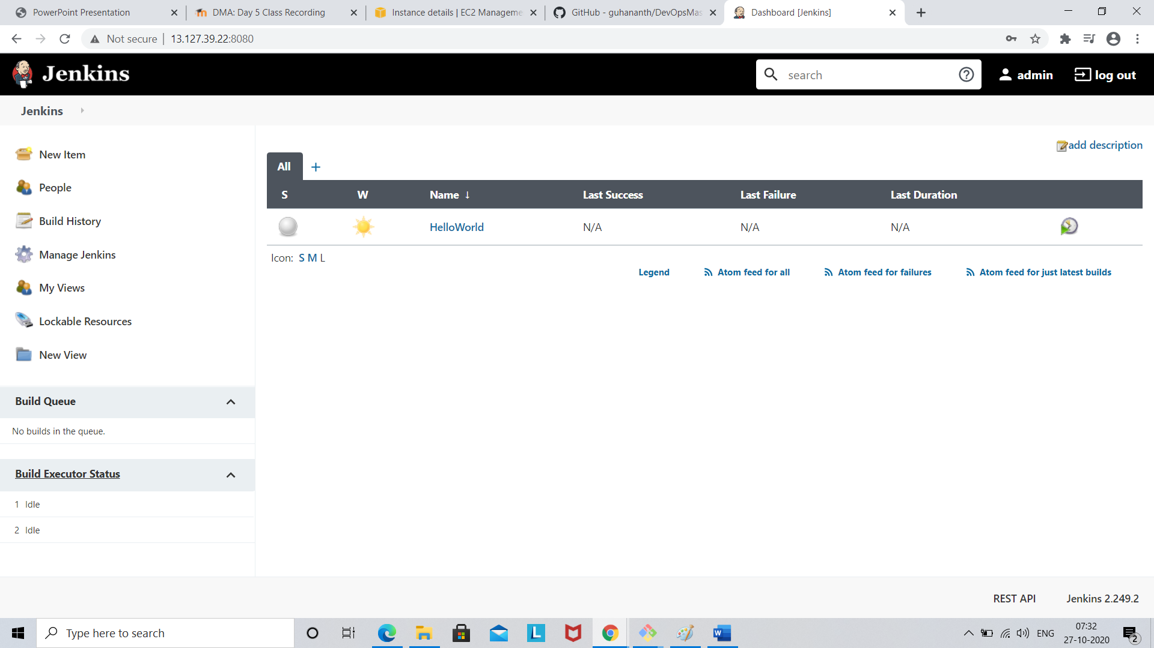

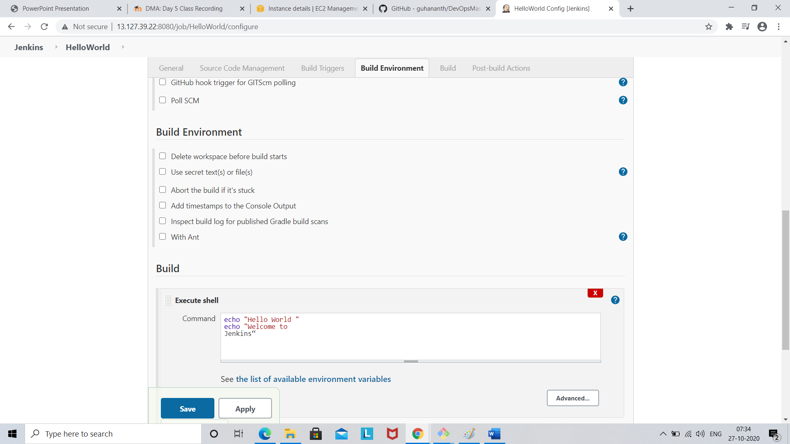

Click save

Then build now option

